Dustin Qualley

November 5, 2019

Foundations of Programming: Python

Assignment05

**Python Script on Reading and Writing to Dictionary**

**Introduction**

In this document I will illustrate the use of multiple features and functions in the Python programming language to present a program that reads a .txt file, allows a user to add/remove items on a list, convert the list to a dictionary, and save the file.

**Building a List and Dictionary**

In Figure 1, after the user selects from the Menu of Options, selection 1 opens a .txt file and reads the rows, split by commas. The row is converted into a dictionary and each value is assigned to “Task” or “Priority.” The table in the list is appended and the file closes.

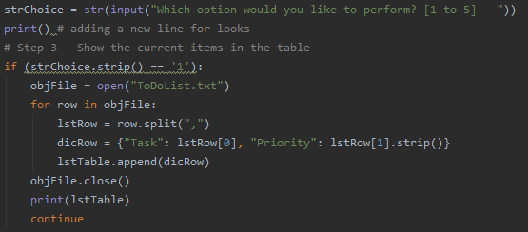

***Figure 1***

The next option allows the user to add a task and priority to the dictionary, and “lstTable” is appended. Option 3 allows the user to delete a task from the dictionary. A conditional statement allows for the code to delete the task if it is in the dictionary or tell the user the selected task is not in the dictionary. The code can be seen in Figure 2 and in an OS command window in Figure 3.

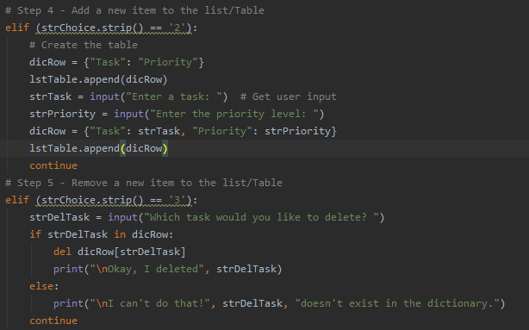

***Figure 2***

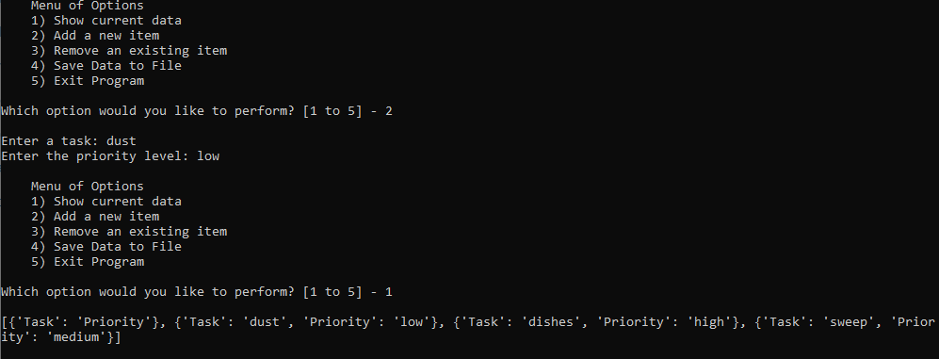

***Figure 3***

A screenshot in PyCharm is below in Figure 4.

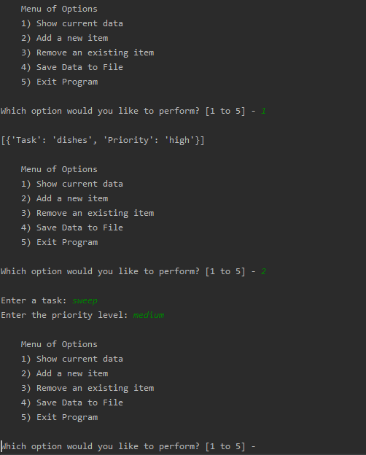

***Figure 4***

In Step 6, the user is given the option to save the data to the file, “ToDoList.txt.” The code opens the file, writes the new “Task” and “Priority,” closes the file, and tells the user the data has been saved. Step 7 allows the user to exit the program. See Figure 5.

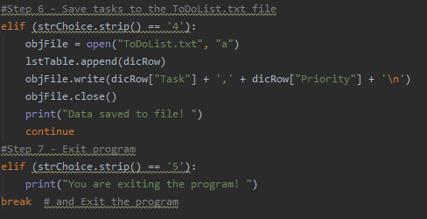

***Figure 5***

Figure 6 below shows this in PYCharm.

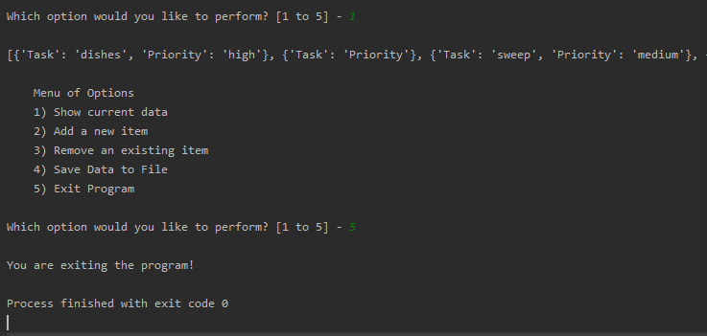

***Figure 6***

**Summary**

This program illustrates several features in the python program, including conditional statements, loops, reading/writing to a .txt file, creating lists and dictionaries.